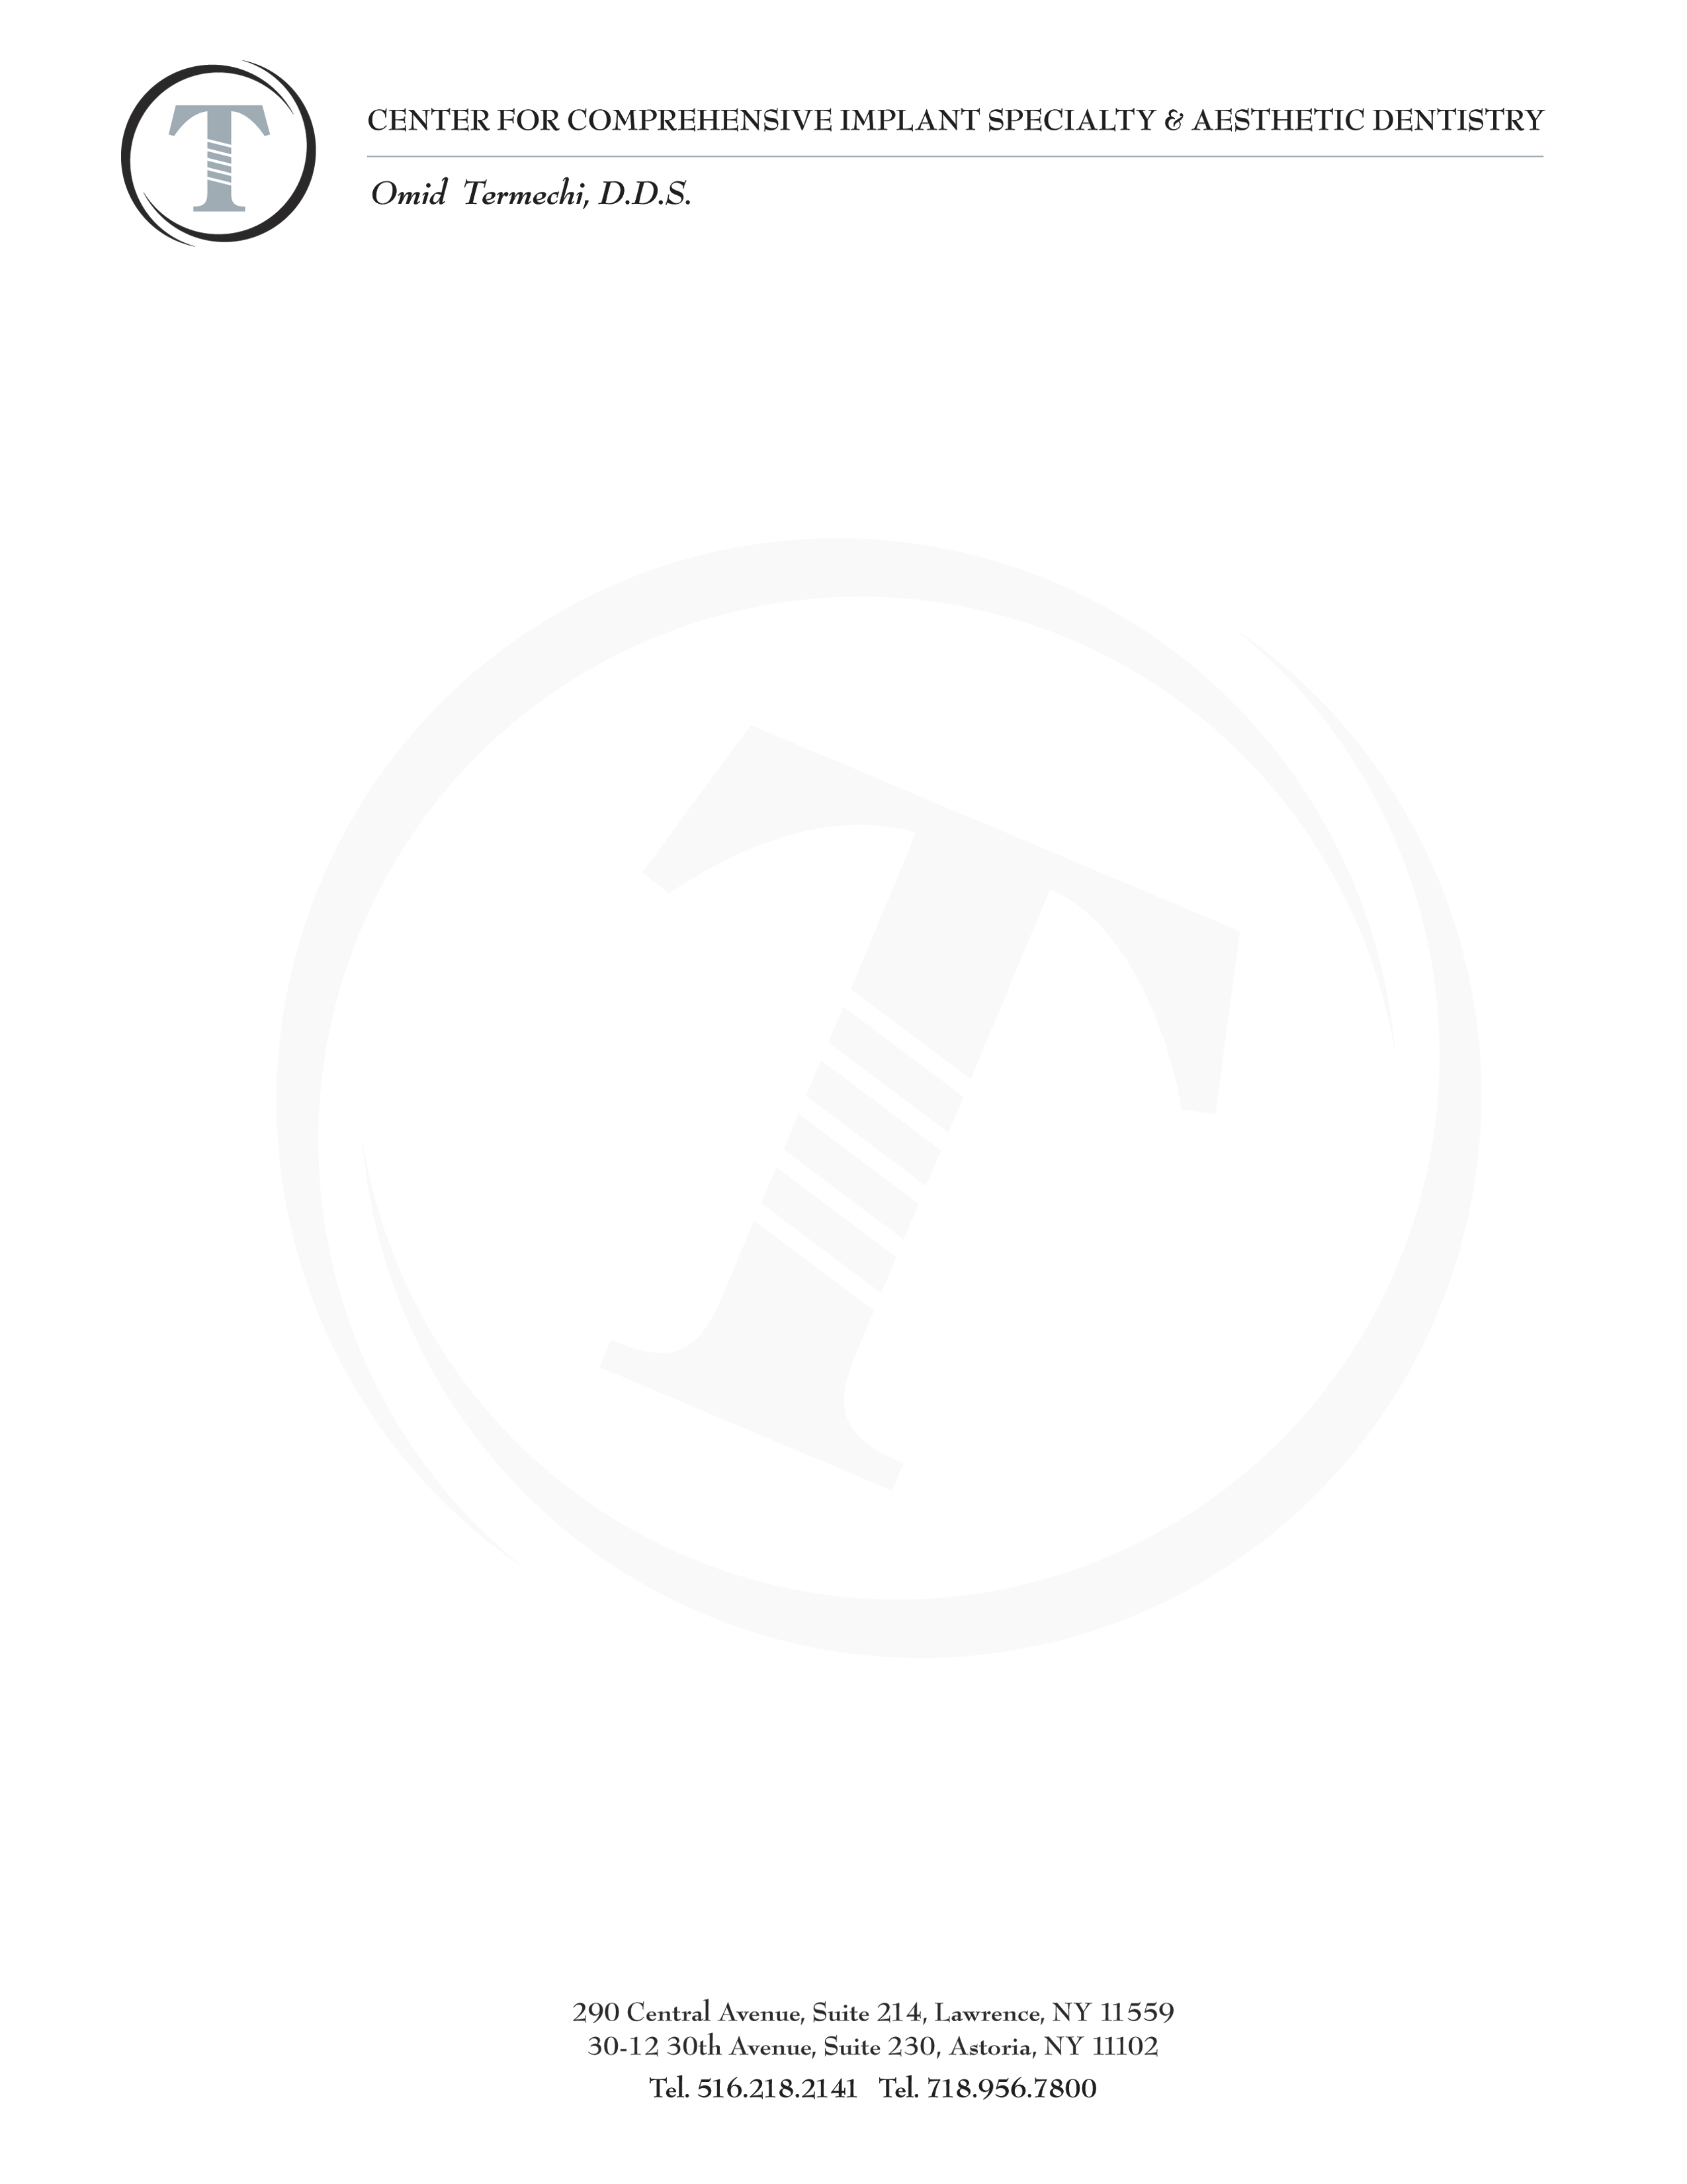
Pre-Surgery Instructions

Before your surgery
If you are on an aspirin regimen or are currently taking any blood thinners and we have not given you
instructions regarding the necessity to interrupt your medications, please bring it to our attention before the day of your surgery

Pick up your prescriptions before your surgery day, you may need to take certain medications up to a day before in preparation for your procedure.

If you are having sinus bone graft, do not plan on flying for at least two weeks after surgery.

Prepare an ice pack at home to use after the surgery. Frozen peas work well.

Day of the surgery
If you are having any type of sedation, please bring someone with you who is able to drive or accompany you home.

If you wish you may eat a light meal before surgery
Wear comfortable, loose fitting clothing
Please remove all jewelry, (earrings, necklaces, bracelets).

Make sure you have read your Surgery Consent Form prior to the day of surgery and jot down any questions you may have. Bring in the consent form so you can sign it in the office.

After Surgery
Beginning the day after surgery rinse with warm salt water. 8 oz of water 1/2 teaspoon of salt.
4-6 times a day for 5 days.
Gently rinse with Listerine or Peridex the day after the surgery then do not eat or drink for 30 minutes.
2nd week gently swab surgical area with Listerine or Peridex using a Q-Tip.

You will need to be on a soft diet from the day of the surgery to the end of the week. Example:
- scrambled eggs, mashed potatoes, yogurt, soup, oatmeal, ice-cream, applesauce, bananas, pasta, tuna; anything you can cut with your fork.

You may want to place a towel on your pillow for several nights after the surgery so you can protect your linen from blood due to drooling.

Please note that all surgical appointments cancelled without a 72 hour notice is subject to a $500 non refundable cancellation fee.

